AI Insdide-Yolov8 Adaptation Instructions

Overview
DJI plans to open up its internal computing power to help users deploy locally trained target recognition networks (yolov8) on industrial drones.
Currently, DJI only adapts to a typical network model structure, and requires users to apply git patch files based on the yolov8 open source project for training. In addition, considering computing efficiency and flight safety, some network parameters currently do not support modification.
After training the model, the user need select the related pth file and submits it to DJI together with the necessary files to complete subsequent model quantization and other operations, and convert it into a file format that can be run by the drone. Then, the network model is loaded on the drone and the target is recognized by uploading it through the APP.

Network Model Adaptation and Training
- Download mmyolo project from github：https://github.com/open-mmlab/mmyolo
- Switch mmyolo to tag v0.6.0
- Apply the git patch file
- Train the network model according to the officially recommended configfile . The config file used is limited to yolov8_s_syncbn_fast_8xb16-500e_coco.py. Training command example：CUDA_VISIBLE_DEVICES=0,1,2,3 ./tools/dist_train.sh configs/yolov8/yolov8_s_syncbn_fast_8xb16-500e_coco.py 4
- Control the number of recognition categories not to exceed 10, that is, num_classes <= 10 in config file
- After the locally trained model meets the requirements, the corresponding pth file and quantitative calibration images need be sent to DJI. DJI will complete the subsequent evaluation and testing work

Important tips
To run the 4K resolution model, first change widen_factor from 0.5 to 0.25 in yolov8_s_syncbn_fast_8xb16-500e_coco.py; otherwise, the quantization stage will fail (calibration/validation will not pass).

Some Parameters That Cannot Be Modified
Parameters of “model related” cannot be modified：
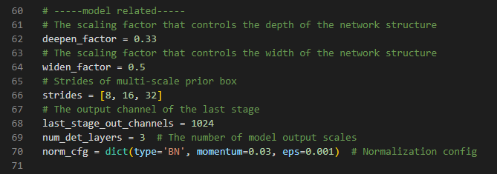
Parameters of “Unmodified in most cases” cannot be modified：
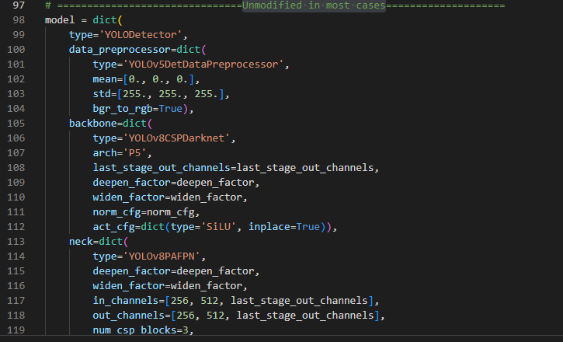

Files and Parameters That Need to Be Provided to DJI For Quantification
- Related pth file
- Calibration images for quantization（500-1000 images are recommended）
- Algorithm parameters related to output target box:
